

##### A PROJECT REPORT ON (ARTIFICIAL INTELLIGENCE IN BUSINESS PLAN)

Submitted in partial fulfilment of the requirements For the award of degree

Of

BACHELORS OF BUSINESS ADMINISTRATION SESSION (2022-23)

Submitted to Submitted by

Mr. Ankit Tiwari Aman Kumar Dwivedi Roll No.:

220014000510

Class :

BBA I Year II semester



##### AXIS INSTITUTE OF HIGHER EDUCATION (KN115) ROOMA, KANPUR (UP)

**DECLARATION**

I hereby declare that the project report entitled “A case study on **Artificial Intellingence**

”

Submitted to **Axis institute of higher education, Kanpur** in partial fulfillment of Degree

Of Bachelor of Business Administration is the original work conducted by me.

The information and data given in the report is authentic to the best of my knowledge.

The project report is not being submitted to any other University for award of any other Degree, Diploma and Fellowship.

**Place: Kanpur Mohit kumar**

**Date Roll No.: 23070000984**



#### COLLEGE CERTIFICATE

Certified that this project report entitled “A CASE STUDY ON ARTIFICIAL

INTELLIGENCE ” has been prepared by MR. MOHIT KUMAR of BBA

Semester II during session under my supervision.

The project report is up to the standard and I forward it to the director AXIS INSTITUTE OF HIGHER EDUCATION for getting it evaluated as per the ordinances governing the BBA course.

MRS. Kriti Shukla

…………………….

(Signature) Date:

(KANPUR)

#### The whole project has been divided into 5 chapters.

* Introduction
* Benefits of AI
* Future of AI
* Common use AI
* Related Article in AI
* Business plan in AI
* Conclusion

#### PREFACE

It is a great opportunity for me to have the **BACHELOR OF BUSINESS ADMINISTRATION** (BBA) in **AXIS INSTITUTE OF HIGHER EDUCATION,**

**KANPUR**. In the accomplishment of this degree I am submitting a project report on “**A Case Study On Artificial Intelligence** ”. Subject to the limitation of time effort and resources every possible attempt has been made to study the problem deeply.

ACKNOWLEDGEMENT

I have taken efforts in this project. However, it would not have been possible without the kind support and help of many individuals and organizations. I would like to extend my brother.

I am highly indebte **to MRS. KRITI SHUKLA** for their guidance and constant

supervision as well as for providing necessary information regarding the project & also for their support in completing the project.

I would like to express my gratitude towards my parents & member of **AXIS**

**INSTITUTE OF HIGHER EDUCATION (AIHE)** for their kind co-operation and encouragement which help me in completion of this project.

I would like to express my special gratitude and thanks to my professor for giving me such attention and time.

My thanks and appreciations also go to my friends in developing the project and people who have willingly helped me out with their abilities.

**CHAPTER-1 INTRODUCTION**

### Introduction to AI Based Business Plan

An AI based business plan is a document that uses artificial intelligence technology to analyze and generate insights about your business, market, and competition. By using machine learning algorithms, natural language processing, and data analytics, an AI based business plan can provide valuable insights and recommendations to help entrepreneurs create a more effective plan.

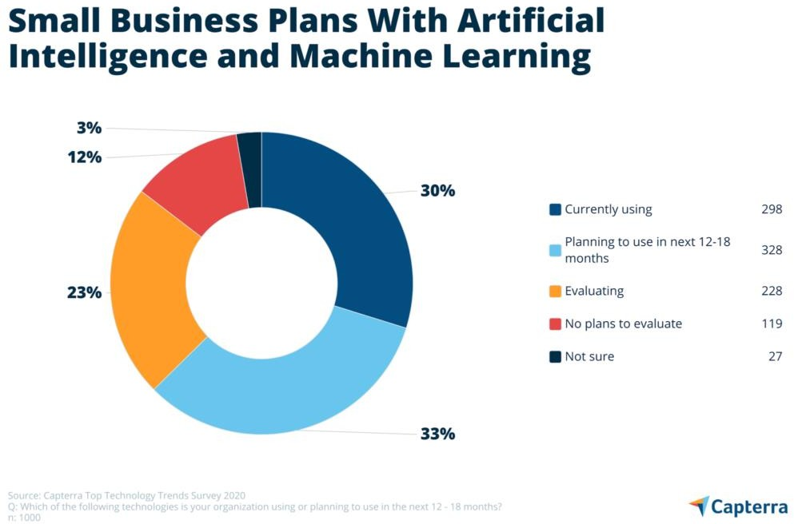

What is AI?

Before examining how AI technologies are impacting the business world,

it’s important to define the term. “Artificial intelligence” is a broad term that refers to any type of computer software that engages in humanlike activities

– including learning, planning and problem-solving. Calling specific

applications “artificial intelligence” is like calling a car a “vehicle” – it’s technically correct, but it doesn’t cover any of the specifics. To understand what type of AI is predominant in business, we have to dig deeper.

**CHAPTER-2**

**Benefits of Using AI Business Plan**

### Benefits of Using AI Business Plan

**Using AI business plan can have many benefits, including:** Benefits of Using AI Business Plan

Using AI business plan can have many benefits, including:

* ***Enhanced Data Analysis***: AI can quickly analyse large amounts of data and provide insights that would be difficult or impossible to uncover manually.
* ***Faster Decision Making***: By using AI, entrepreneurs can quickly generate insights and recommendations to make faster and better decisions.
  + ***Increased Accuracy***: AI business plans are less prone to errors and bias, which can improve the accuracy and effectiveness of the plan.
* ***Improved Collaboration***: AI based business plans can be easily shared and accessed by team members, making it easier to collaborate and make decisions

together

* + ***Market Data Analysis***: AI can quickly analyse large amounts of data and provide insights that would be difficult or impossible to uncover manually.
* ***Faster Decision Making***: By using AI, entrepreneurs can quickly generate insights and recommendations to make faster and better decisions.
  + ***Increased Accuracy***: AI business plans are less prone to errors and bias, which can improve the accuracy and effectiveness of the plan.
* ***Improved Collaboration***: AI based business plans can be easily shared and accessed by team members, making it easier to collaborate and make decisions

together.

***How to Create AI Pitch Decks for Your Business Plan?***

An AI-based pitch deck is a presentation that highlights the key elements of your AI based business plan. It is a crucial component of your fundraising efforts and serves to showcase your idea to potential investors. Here are some tips on how to create an effective AI pitch deck:

* ***Start with a Compelling Introduction***: Your introduction should grab the attention of your audience and clearly communicate your value proposition. Use AI-generated insights to highlight the market opportunity and the unique problem your product or

service is solving.

• ***Define Your Target Market***: Use AI-generated data to define your target market and explain why it is a valuable opportunity. Be specific about the demographics and

psychographics of your target customers.

• ***Explain Your Solution***: Use AI-generated insights to explain how your AI-based product or service solves the problem you have identified. Provide examples of how

your solution has already been successful in the market.

• ***Showcase Your Team***: Use AI to analyse the skills and experience of your team members and highlight their strengths in your pitch deck. This can help build

credibility and trust with potential investors.

• ***Highlight Your Revenue Model***: Use AI-generated insights to explain your revenue model and provide financial projections. Be realistic and transparent about your

financials and explain how you plan to make money.

• ***Provide a Clear Ask***: End your pitch deck with a clear ask for investment. Provide details on how much money you are seeking, how you plan to use the funds, and what

the investor can expect in return.

* ***Use Visuals***: Incorporate visuals and graphics to make your pitch deck more engaging and memorable. Use AI-generated images to showcase your product or service in

action and use graphs and charts to illustrate your financial projections.

Creating an AI pitch deck requires careful planning and attention to detail. By leveraging AI-generated insights and data, you can create a compelling and effective pitch deck that highlights the unique value of your AI-based business plan. Remember to keep your pitch deck concise, clear, and engaging, and always tailor it to your audience. With a well-crafted [pitch deck,](https://www.planwriters.net/pitch-deck) you can attract the investment you need to turn your AI-based business idea into a reality.

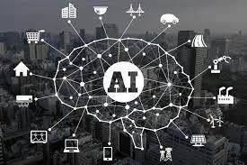

*AI Startup Business Plan – Essential Elements to Include*

Creating an AI startup business plan requires careful consideration of several key elements that are critical to success. Here are some essential elements to include in your AI startup business plan:

* + ***Executive Summary:*** The executive summary is the first section of your business plan and should provide a brief overview of your AI-based business idea, the market

opportunity, and the key highlights of your plan.

* + - ***Market Analysis:*** Use AI-generated data to analyse the market opportunity and identify the target audience for your product or service. Include details on your competitors, their strengths, and weaknesses, and how you plan to differentiate

yourself in the market.

* + ***Product or Service Offering***: Describe your AI-based product or service in detail, highlighting its unique features and benefits. Use AI-generated insights to explain

how your product or service solves a problem in the market.

* ***Business Model:*** Explain how you plan to make money and generate revenue from your AI-based business. Use AI-generated financial projections to demonstrate the

viability of your business model.

* ***Marketing and Sales Strategy***: Outline your marketing and sales strategy, including how you plan to reach and engage with your target audience, and how you plan to

convert leads into paying customers.

* ***Management Team:*** Provide details on the experience and skills of your management team, highlighting their strengths and contributions to the success of your AI-based

business.

* + ***Financial Projections***: Use AI-generated financial projections to demonstrate the profitability and growth potential of your AI-based business.

Including these essential elements in your AI startup business plan can help you to create a comprehensive and effective plan that outlines the key components of your business idea and demonstrates its potential for success. By leveraging AI-generated data and insights, you can create a plan that is informed by accurate and actionable data and sets your AI-based business up for success.

*Best AI Pitch Decks – Examples and Tips*

Creating an effective AI pitch deck is essential for attracting potential investors to your [**AI-based business**](https://www.planwriters.net/). To help inspire and guide you, here are some tips and examples of the [**best AI pitch decks**](https://www.planwriters.net/pitch-deck):

* + - Use simple, clear language and visuals to convey your message.
* Highlight the problem your AI-based product or service is solving.
  + Use AI-generated data to showcase the market opportunity and growth potential.
    - Include financial projections and a clear ask for investment.

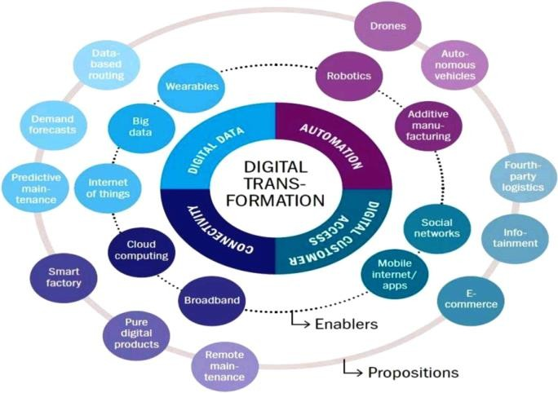*How many businesses use AI?*

*37% of businesses and organizations employ AI. Nine out of ten leading businesses have investments in AI technologies, but less than 15% deploy AI capabilities in their work. The rise of AI will eliminate 85 million jobs and create 97 million new ones by 2025.*

**Key AI Statistics**

1. The global AI market value is expected to reach $267 billion by 2027.
2. AI is expected to contribute $15.7 trillion to the global economy by 2030
3. 37% of businesses and organizations employ AI.
4. Nine out of ten leading businesses have investments in AI technologies, but less than 15% deploy AI capabilities in their work.
5. The rise of AI will eliminate 85 million jobs and create 97 million new ones by 2025
6. More than three billion voice assistants are now in use, and eight billion will be by 2023.
7. The AI industry will be earning $126 billion a year by 2025.

8.67% of Americans believe self-driving cars are safer than regular cars.

1. 25 countries are now working on designing autonomous vehicles.
2. 25 countries are now working on designing autonomous vehicles.

**CHAPTER-3** **FUTURE OF AI**

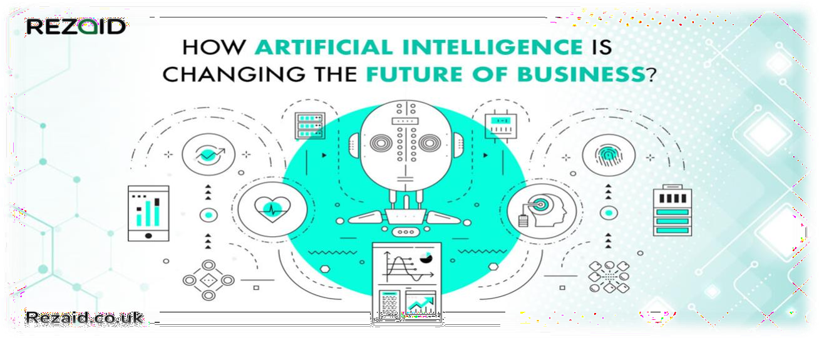

The future of AI How might artificial intelligence be used in the future? It’s hard to say how the technology will develop, but most experts see those

“commonsense” tasks becoming even easier for computers to process. That means robots will become extremely useful in everyday life.

“AI is starting to make what was once considered impossible possible, like driverless cars,” said Russell Glenister, CEO and founder of Curation Zone. “Driverless cars are only a reality because of access to training data and fast GPUs, which are both key enablers. To train driverless cars, an enormous amount of accurate data is required, and speed is key to undertake the training. Five years ago, the processors were too slow, but the introduction of GPUs made it all possible.”

Glenister added that graphic processing units (GPUs) are only going to get faster, improving the applications of artificial intelligence software across the board.

“Fast processes and lots of clean data are key to the success of AI,” he said.

Dr. Nathan Wilson, co-founder and CTO of Nara Logics, said he sees AI on the cusp of revolutionizing familiar activities like dining. Wilson predicted that AI could be used by a restaurant to decide which music to play based on the interests of the guests in attendance. Artificial intelligence could even alter the appearance of the wallpaper based on what the technology

What will be the future of artificial intelligence?

The productivity of artificial intelligence may boost our workplaces, which will benefit people by enabling them to do more work. As the future of AI replaces tedious or dangerous tasks, the human workforce is liberated to focus on tasks for which they are more equipped, such as those requiring creativity and empathy

anticipates the aesthetic preferences of the crowd might be.

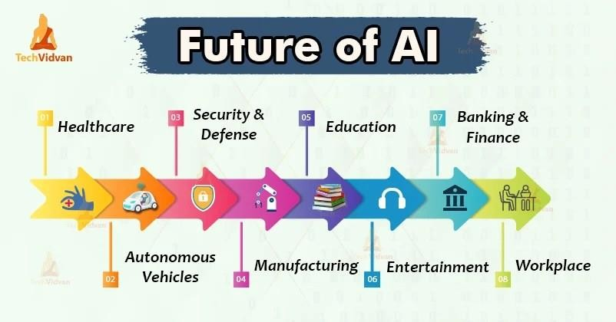

If that isn’t far out enough for you, Rahnama predicted that AI will take digital technology out of the two-dimensional, screen-imprisoned form to which people have grown accustomed. Instead, he foresees that the primary user interface will become the physical environment surrounding an individual.

“We’ve always relied on a two-dimensional display to play a game or interact with a webpage or read an e-book,” Rahnama said. “What’s going to happen now with artificial intelligence and a combination of [the Internet of Things] is that the display won’t be the main interface – the environment will be. You’ll see people designing experiences around them, whether it’s in connected buildings or connected boardrooms. These will be 3D

experiences you can actually feel.” **[Interacting with digital overlays in your immediate environment? Sounds like a job for** [**augmented reality**](https://www.businessnewsdaily.com/10588-get-job-in-virtual-augmented-reality.html)**.]** No one can prognosticate what the future will bring, but AI may



ultimately produce more jobs than it displaces. Offering new tools for entrepreneurs can also produce new areas of business that

**CHAPTER-4 COMMON USES OF ARTIFICIAL**

**INTELLIGENCE**

COMMON USES OF ARTIFICIAL INTELLIGENCE

**Let's dive in and look at the most common and useful cases of AI in business!**

* Artificial Intelligence in Sales. ...
* Artificial Intelligence in Marketing. ...
* Artificial Intelligence in Customer Support. ...
* Artificial Intelligence in Human Resources. ...
* Artificial Intelligence in Accounting…

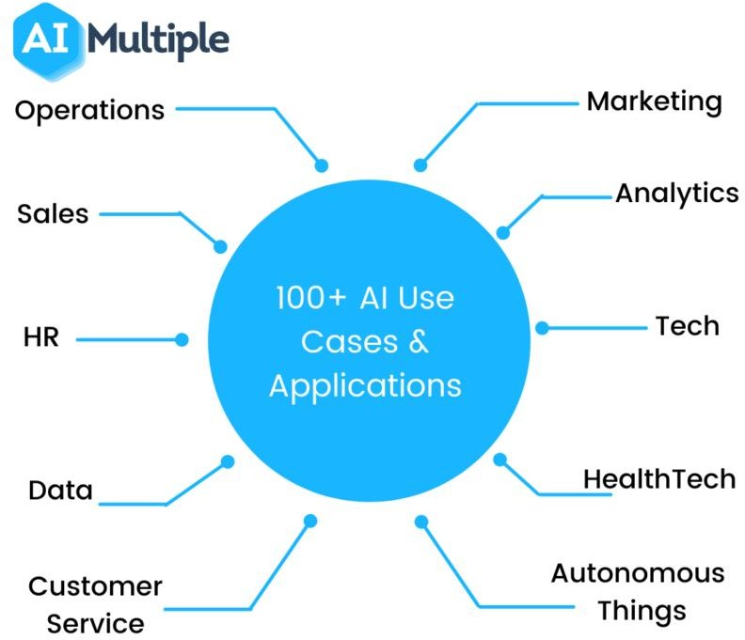

Artificial Intelligence in Sales-

AI in sales can be used to help manage and predict customer behavior, identify cross-selling and upselling opportunities, automate repetitive tasks, and improve forecasting accuracy..

Artificial Intelligence in Marketing-

AI marketing, which can be considered new marketing for showing a particular marketing plan by incorporating Artificial intelligence into traditional processes, also known as artificial intelligence marketing, uses machine learning, natural language processing, and other AI technologies to analyze customer data,

Artificial Intelligence in Customer Support-

AI customer service is an artificial intelligence system that interacts with customers on behalf of a company. The AI system is programmed to respond to customer queries and requests, and it can simulate a human conversation by using natural language processing



Artificial Intelligence in Human Resources-

The key components of your human resources business plan should include your organizational structure, the philosophy and needs of your HR department, the number of employees you want to hire, how you plan to manage them, and all the estimated costs related with personnel.

Artificial Intelligence in Accounting-

The most common use for AI in accounting is to take care of repetitive tasks. For example, AI systems can capably, and with minimal error, complete tasks that include the following: Inputting and matching data. Receipt reconciliation

What does AI mean for the worker?

With all these new AI uses comes the daunting question of whether machines will force humans out of work. The jury is still out: Some experts vehemently deny that AI will automate so many jobs that millions of people find themselves unemployed, while other experts see it as a pressing problem.

“The [structure of the workforce is changing](https://www.businessnewsdaily.com/15798-types-of-organizational-structures.html), but I don’t think artificial intelligence is essentially replacing jobs,” Rahnama said. “It allows us to really create a knowledge-based economy and leverage that to create better automation for a better form of life. It might be a little bit theoretical, but I think if you have to worry about artificial intelligence and robots replacing our jobs, it’s probably algorithms replacing white-collar jobs such as business analysts, hedge fund managers and lawyers.”

Artificial intelligence (AI) refers to the ability of machines to understand the world around them, learn and make decisions, in a similar way to the human brain. Thanks to AI, machines are getting smarter every day.

The 4 types of AI

**4 main types of artificial intelligence**

* Reactive machines ...
* Limited memory ...
* Theory of mind ...
* Self-awarene…

We are further down the road of A.I. As we grow in understanding, so, too, do we grow to understand its differences.

In 2020, we can classify [artificial intelligence](https://www.bmc.com/blogs/artificial-intelligence-vs-machine-learning/) into 4 distinct types. The types are loosely similar to [Maslov’s hierarchy of needs](https://en.wikipedia.org/wiki/Maslow%27s_hierarchy_of_needs), where the simplest level only requires basic functioning and the most advanced level is the Mohammad, Buddha, Christian Saint, all-knowing, all-seeing, self-aware consciousness.

The four A.I. types are

1. Reactive Machines
2. Limited Memory
3. Theory of Mind
4. Self Aware

We are currently well past the first type and actively perfecting the second. At the moment, the third and fourth types exist only in theory. They are to be the next stage of A.I.—let’s take a look.

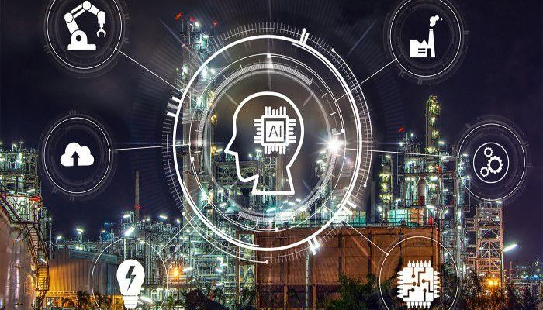

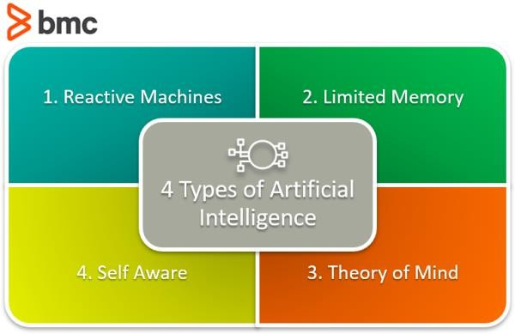

**Reactive Machines**

Reactive Machines perform basic operations. This level of A.I. is the simplest. These types react to some input with some output. There is no learning that occurs. This is the first stage to any A.I. system. A [machine](https://www.bmc.com/blogs/machine-learning-cybersecurity/) [learning](https://www.bmc.com/blogs/machine-learning-cybersecurity/) that takes a human face as input and outputs a box around the face to identify it as a face is a simple, reactive machine. The model stores no inputs, it performs no learning.

Static [machine learning models](https://www.bmc.com/blogs/supervised-vs-unsupervised-aiops-machine-learning/) are reactive machines. Their architecture is the simplest and they can be found on GitHub repos across the web. These models can be downloaded, traded, passed around and loaded into a developer’s toolkit with ease.

**Limited Memory**

Limited memory types refer to an A.I.’s ability to store previous data and/or predictions, using that data to make better predictions. With Limited Memory, machine learning architecture becomes a little more complex.

Every machine learning model requires limited memory to be created, but the model can get deployed as a reactive machine type.

There are three major kinds of machine learning models that achieve this Limited Memory type:

Reinforcement learning

These models learn to make better predictions through many cycles of trial and error. This kind of model is used to teach computers how to play games like Chess, Go, and DOTA2.

Long Short Term Memory (LSTMs)

Researchers intuited that past data would help predict the next items in sequences, particularly [in language](https://www.bmc.com/blogs/nlu-vs-nlp-natural-language-understanding-processing/), so they developed a model that used what was called the Long Short Term Memory. For predicting the next elements in a sequence, the LSTM tags more recent information as more important and items further in the past as less important.

Evolutionary Generative Adversarial Networks (E-GAN)

[The E-GAN](https://arxiv.org/pdf/1803.00657.pdf) has memory such that it evolves at every evolution. The model produces a kind of growing *thing*. Growing *things* don’t take the same path every time, the paths get to be slightly modified because statistics is a math of chance, not a math of exactness. In the modifications, the model may find a better path, a path of least resistance. The next generation of the model mutates and evolves towards the path its ancestor found in error.

In a way, the E-GAN creates a simulation similar to how humans have evolved on this planet. Each child, in perfect, successful reproduction, is better equipped to live an extraordinary life than its parent.

Limited Memory Types in practice

While every machine learning model is created using limited memory, they don’t always become that way when deployed.

Limited Memory A.I. works in two ways:

1. A team continuously trains a model on new data.
2. The A.I. environment is built in a way where models are automatically trained and renewed upon model usage and behavior.

For a machine learning infrastructure to sustain a limited memory type, the infrastructure requires machine learning to be built-in to its structure.

More and more common in the ML lifecycle is Active Learning. The ML Active Learning Cycle has six steps:

1. **Training Data**. An ML model must have data to train on.
2. **Build ML Model**. The model is created.
3. **Model Predictions**. The model makes predictions,
4. **Feedback**. The model gets feedback on its prediction from human or environmental stimuli.
5. **Feedback becomes data**. Feedback is submitted back to a data repository.
6. **Repeat Step 1**. Continue to iterate on this cycle.

**Theory of Mind**

We have yet to reach Theory of Mind artificial intelligence types. These are only in their beginning phases and can be seen in things like self-driving cars. In this type of A.I., **A.I. begins to interact with the thoughts and emotions of humans**.

Presently, machine learning models do a lot for a person directed at achieving a task. Current models have a one-way relationship with A.I. Alexa and Siri bow to every command. If you angrily yell at Google Maps to take you another direction, it does not offer emotional support and say, “This is the fastest direction. Who may I call and inform you will be late?”

Google Maps, instead, continues to return the same traffic reports and ETAs that it had already shown and has no concern for your distress.

*A Theory of Mind A.I. will be a better companion.*

Fields of study tackling this issue include Artificial Emotional Intelligence and developments in the theory of [Decision-Making](https://on.acm.org/t/the-decision-making-side-of-machine-learning-computational-inferential-and-economic-perspectives/1591). Michael Jordan presented some of his Decision-Making research at the May 13th event, [The](https://iclr.cc/virtual_2020/speaker_8.html) [Future of ML and AI with Michael Jordan and Ion Stoica](https://iclr.cc/virtual_2020/speaker_8.html), and more coverage was presented at the [ICLR 2020](https://medium.com/%40ericeallen/our-favorite-papers-from-iclr-2020-7b7d5791f487) conference.

**Self-Aware**

Finally, in some distant future, perhaps A.I. achieves nirvana. It becomes self-aware. This kind of A.I. exists only in story, and, as stories often do, instills both immense amounts of hope and fear into audiences. A self-aware intelligence beyond the human has an independent intelligence, and likely, people will have to negotiate terms with the entity it created. What happens, good or bad, is anyone’s guess.

**Are there other AI types?**

There are other types of A.I. the more tech-oriented crowd observes. They follow a similar outline but get written about with a stronger foundation in what the A.I. is used for, what it is capable of, and how it helps advance humanity. These three types are:

* Artificial Narrow Intelligence
* Artificial General Intelligence
* Artificial Super Intelligence

Whichever way you break down A.I., know that it A.I. is a strong software tool for the future that’s here to stay. A.I. is eliminating repetitive tasks in the workforce and elevating humans to reach higher selves, embracing constant states of change and creativity.

**Related reading**

* [BMC Machine Learning & Big Data Blog](https://www.bmc.com/blogs/categories/machine-learning-big-data/)
* [Artificial Artificial Intelligence: What Is It?](https://www.bmc.com/blogs/artificial-artificial-intelligence/)
* [What Is AIaaS? AI as a Service Explained](https://www.bmc.com/blogs/ai-as-a-service-aiaas/)
* [Mindful AI](https://www.bmc.com/blogs/mindful-ai/)
* [Top 5 Machine Learning Algorithms for Beginners](https://www.bmc.com/blogs/machine-learning-algorithms/)
* [5 Tribes of Machine Learning](https://www.bmc.com/blogs/machine-learning-tribes/)

What about after the transition?

First and foremost, this is a transition that will take years – if not decades – across different sectors of the workforce. So, these projections are harder to identify, but some other experts like Husain are worried that once AI becomes ubiquitous, those additional jobs (and the ones that had already existed) may start to dwindle.

Because of this, Husain said he wonders where those workers will go in the long term. “In the past, there were opportunities to move from farming to manufacturing to services. Now, that’s not the case. Why? Industry has been completely robotized, and we see that [automation makes more sense](https://www.businessnewsdaily.com/15909-workplace-automation-benefits.html) [economically](https://www.businessnewsdaily.com/15909-workplace-automation-benefits.html).”

Husain pointed to self-driving trucks and AI concierges like Siri and Cortana as examples, stating that as these technologies improve, widespread use could eliminate as many as 8 million jobs in the U.S. alone.

“When all these jobs start going away, we need to ask, ‘What is it that makes us productive? What d oes productivity mean?'” he added. “Now we’re confronting the changing reality and questioning society’s underlying assumptions. We must really think about this and decide what makes us productive and what is the value of people in society. We need to have this debate and have it quickly, because the technology won’t wait for us.”

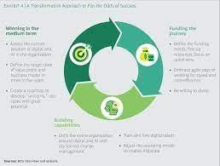

## CHAPTER-5

**RELATED ARTICLES OF ARTIFICIAL INTELLIGENCE**

#### RELATED ARTICLES OF ARTIFICIAL INTELLIGENCE

Automation is a broad concept that applies to modern workplaces in more ways than the obvious. How is your workplace already automated?

* Workplace automation is widely available, often taking the form of software tools in commonly used programs.
* There’s scope for greater automation in almost any business, across all industries.
* Automation won’t replace people, but it will free them from performing mundane and repetitive tasks.

###### This article is for business owners keen to know how workplace automation could benefit their business by freeing up resources and improving consistency.

There was a time when the term “automation” was synonymous with advanced manufacturing plants full of robotics. While replacing human

labor with machine labor is a prime example of workplace automation, it’s far from the only example. Automation is present in modern businesses of all sizes – including subtle features in common software applications, and more obvious implementations like self-driving vehicles or autonomous robots.

There is much debate about where workplace automation will lead the economy, but observers tend to agree that the trend is gaining momentum. Every business process is on the table for automation, especially as

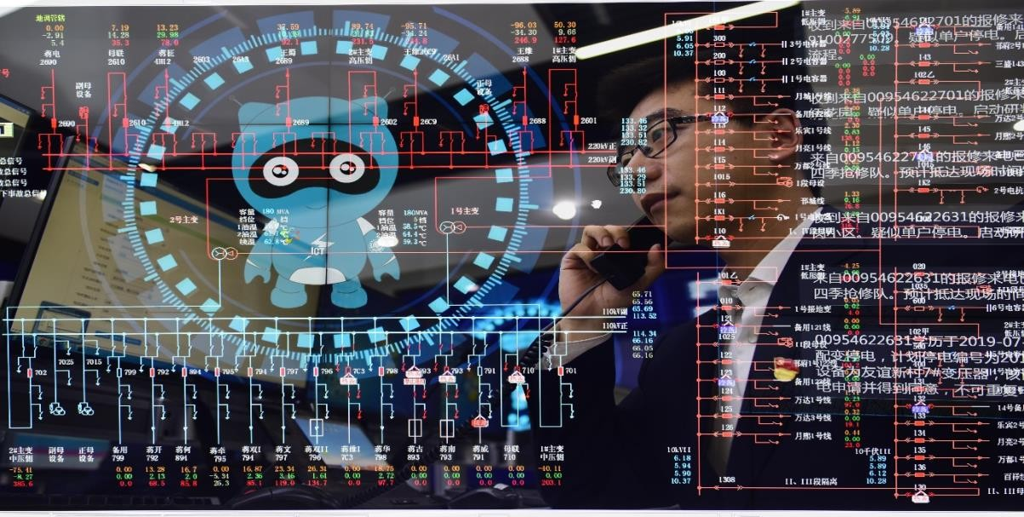

technology becomes more sophisticated. Automation will undoubtedly change the workplace and the wider economy. The only question is: To what extent?

#### Workplace automation

There’s a common misconception that automation involves towering robotics, but it can be as simple as a set of tools housed within common [business software](https://www.businessnewsdaily.com/330-small-business-software-needs-guide.html) programs. At its core, automation is about

implementing a system to complete repetitive and easily replicated tasks without the need for human labor.

“Automation takes a lot of forms,” said Fred Townes, chief product officer at READY Education. “For small businesses, the most important thing is [repetition]. When you find something you do more than once that adds value … you want to look into automation.”

Historically, automation required expensive servers and a team of experts to maintain them. For many small businesses, this was a cost-prohibitive measure that put automation out of reach. With the development of cloud- based platforms, however, automation tools are now accessible to even the smallest companies, Townes said.

and repetitive nature of HR duties – like payroll and timesheets – digitization can transform the efficiency of a department. By reducing mistakes caused by human error, such as an HR employee forgetting to update submitted timesheets, it’s possible to automate performance management, paid holidays and absenteeism record keeping.

Software can raise flags if quotas are reached or missed, while maintaining accurate records updated in real time. There are e

Businesses use customer relationship management to help automate the process of finding and retaining customers. We’ve reviewed the leading names, and you can see who ranked the highest on our [best CRM](https://www.businessnewsdaily.com/7839-best-crm-software.html) [software](https://www.businessnewsdaily.com/7839-best-crm-software.html) page.

**Did You Know?**

Machine learning as a driver of more sophisticated automation

Machine learning and [artificial intelligence](https://www.businessnewsdaily.com/9402-artificial-intelligence-business-trends.html) enable new forms of “smart” automation. As the software learns, the more adaptable it becomes. These technologies open the door for the automation of higher-order tasks in addition to the basic, repetitive tasks.

“I think there’s a lot of focus at the moment on these tasks that humans don’t want to do,” Sharma said. “But what’s going to happen in the future is

… automation will not just be about automating those tasks humans are doing today, but it will be about realizing potential opportunities.”

As data sets become more thorough and available, and as software draws on more sources and synthesizes more data points, contextual information in human decision-making will only improve. Machine learning will serve as a supplement to – or perhaps even an enhancement to – human knowledge.

Combine AI capabilities with improved data retention through the [Internet](https://www.businessnewsdaily.com/4858-internet-of-things-will-change-work.html) [of Things (IoT)](https://www.businessnewsdaily.com/4858-internet-of-things-will-change-work.html), and the possibilities are endless.

Deus ex machina

Townes proposed that a shift toward more attractive user experiences with machine learning programs is already underway. To make interacting with these tools more natural and intuitive, he said companies will begin tailoring AI and automated technologies for a more organic, human experience.

To make customer service chatbots appear more human, Sage has intentionally built imperfections into its AI. For example, the answer to a user’s question might already be queued up by a chatbot, but Sage built a slight “thinking” delay into its system to simulate a more human customer service interaction. An ellipsis in the chat box indicates that the bot is preparing a response, even though it immediately pulled up the queried information. Initial user feedback to the feature was highly positive, reflecting a desire for a more human interactive experience.

The anthropomorphism (humanization) of technology has been [proven to](https://journals.sagepub.com/doi/full/10.1177/00222429211045687) [improve marketing outcomes](https://journals.sagepub.com/doi/full/10.1177/00222429211045687).

**Key Takeaway**

“Things will get more and more accessible,” Sharma said. “These

technologies will never replace the human being, but they will relieve the human being of the things that are less valuable, relatively speaking. [Humans] will be able to instead focus on those things that require creativity and touch. We’ll see more accessible, better experiences, and we’ll see human beings move to their highest and best use.”

For personnel, the shock of an increasingly automated world can be difficult to process. According to Sharma, successfully integrating automation into human life starts with a comprehensive effort to educate people about what automation is. This also extends to what it isn’t, and what it means for them.

“Users are often initially surprised [by the capabilities of automation],” Sharma added. “The first time they see something automatically there’s a bit of delight, and it’s also a bit scary until you show them the process the software went through. It’s more of an educational challenge, not so much a tech problem.”

Easing the pain of transition

The steady march of workplace automation has prompted discussion about the future of a fully automated economy. Efficiency, convenience and profitability top the list, but so too do concerns about the fate of workers whose jobs are automated out of existence. There are several proposals to support those displaced in an increasingly automated world, such as retraining programs or a [universal basic income](https://www.businessnewsdaily.com/15864-federal-state-minimum-wage-laws.html).

When it comes to supporting those left behind in an automated economy, there are more questions than answers, with many competing perspectives. Some observers, like Jobcase CEO Fred Goff, anticipate that expanded access to educational and networking opportunities will offer workers the opportunity to remake their careers. They will find a way in the new economy to support themselves and their families.

“The same kind of tech that displaces certain workers also opens up new opportunities,” Goff said. “Work life has changed to the point where everyone is essentially their own free agent. Managing yourself has become the theme in the last 10 years, and so we’re trying to empower people through tools and open-ended community.”

Jobcase is a community of 70 million people, including experts and professionals in various industries. In terms of education, Goff pointed to resources like [Khan Academy](https://www.khanacademy.org/), which offers free courses on various topics, such as economics and coding. Certifying the skills learned on these platforms will likely come increasingly from completing freelance tasks, rather than from academic institutions.

“The rise of platforms for gigs and 1099 labor are increasingly breaking down the notion of skill certification,” Goff said. “It might still be difficult to get that full-time job, but building on contracted experience is a way to give that competency verification. In the education and training world, it means decoupling the certification of your education from the delivery of your education.”

###### Key Takeaway

The people you’ve worked with will increasingly serve as proof of your skill set and level of competence, rather than an established institution offering a four-year degree program.

A new model of working

James Wallace, co-founder of Exponential Ventures, sees an automated future that eschews the conventional notion of jobs altogether. Wallace said that by embracing automation and high tech, individuals could be empowered to create incomes on their own. This would negate the need for a traditional, hierarchical company.

“We’re living through unfortunate but necessary pain,” Wallace said. “The conversation should be how to reduce those growing pains. The reality is the ultimate effect of automation is something very positive for everyone.”

He said the economic insecurity displaced workers feel is very real, but automation is not the enemy. Instead, Wallace hopes to educate people about leveraging this powerful technology to create their own incomes – essentially establishing a society of entrepreneurs and small companies.

“If we can establish a way to make sure we all have enough food, clothing and shelter to survive … and allow people to repurpose their gifts, unique

abilities, and enable them to proliferate that and sell it as a good or a service, then we’re adding income,” Wallace said. “We can create an opportunity to generate income for next to nothing, so why not teach people to leverage the tech that disrupted the marketplace in the first place to embrace it and use it for something more in line with who they are, as an expression of their unique abilities?”

Automation for efficiency and profitability

Ironically, the bottom line of business process automation is the bottom line. Automating processes saves time and allows resources to be diverted elsewhere. It means companies can remain smaller and more agile.

Increased efficiency, productivity and lower costs all translate to [healthier](https://www.businessnewsdaily.com/11096-determining-profit-margins.html) [profit margins for businesses](https://www.businessnewsdaily.com/11096-determining-profit-margins.html) – both small and large. The extent to which automation transforms the economy at large remains to be seen, but it

appears inevitable that we’re headed toward a future of more automation. **[Learn more about the** [**best marketing automation**](https://www.businessnewsdaily.com/10129-marketing-automation-guide.html)[**products**](https://www.businessnewsdaily.com/10129-marketing-automation-guide.html) **in our buyer’s guide.]**

What this means for businesses, workers and consumers will be the subject of huge debate moving forward. One thing seems certain, however: If it can be automated, it will be.

*Neil Cumins contributed to the writing and reporting in this article. Source interviews were conducted for a previous version of this article.*

Image Credit:everything possible / Shutterstock

Adam Uzialko

Adam Uzialko Staff Writer

Adam Uzialko is a writer and editor at business.com and Business News Daily. He has 7

years of professional experience with a focus on small businesses and startups. He has covered topics including digital marketing, SEO, business communications, and public policy. He has also written about emerging technologies and their intersection with business, including artificial intelligence, the Internet of Things, and blockchain.

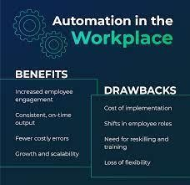

Examples of common workplace automation

Even a garage enterprise with a tiny budget can benefit from automation tools that are hosted and managed by offsite service providers.

According to Townes, by automating repetitive business processes, employees are freed up for tasks that are more valuable than those that can be completed by machines. However, more advanced forms of automation – like machine learning – can now be used to complete higher-order tasks that require a bit more adaptability. The ability of these software programs to

learn over time means they pore through massive troves of data quickly and effectively, before contextualizing that information in a useful way to support internal decision-making.

These are some of the ways in which workplace automation is already being adopted by forward-thinking companies:

###### Email marketing

Many small business owners already use at least one form of

automation: [email marketing](https://www.businessnewsdaily.com/8276-best-email-marketing-software.html). Companies like Zoho and Constant Contact offer software that allows users to tailor the parameters of their email marketing campaign to their liking and then [set it to run automatically](https://www.businessnewsdaily.com/15962-how-crm-streamlines-email-marketing-.html). You can learn more about these platforms’ automation abilities in our [Zoho CRM](https://www.businessnewsdaily.com/10604-best-crm-software-overall.html) [review](https://www.businessnewsdaily.com/10604-best-crm-software-overall.html) and our [review of Constant](https://www.businessnewsdaily.com/16279-constant-contact-email-marketing.html)

[Contact](https://www.businessnewsdaily.com/16279-constant-contact-email-marketing.html). 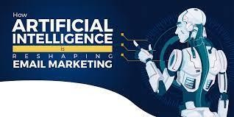.

An introductory email can be uploaded into the software and sent as soon as a contact is added. The [software is configured to send a follow-up email](https://www.businessnewsdaily.com/15882-how-to-create-triggered-emails.html) a few days later, but only to those who opened the original email.

###### Talent acquisition and hiring

Machine learning automation is making inroads in talent acquisition and employee recruitment, said Kriti Sharma, vice president of bots and artificial intelligence at accounting and payroll software company Sage. For human resources departments, automating processes like tracking down potential candidates and scheduling interviews frees up time for workers to determine who is the best fit for their organization. **[Read related article:** [**Guide to**](https://www.businessnewsdaily.com/7477-choosing-payroll-service.html)

###### [Choosing a Payroll Service](https://www.businessnewsdaily.com/7477-choosing-payroll-service.html)]

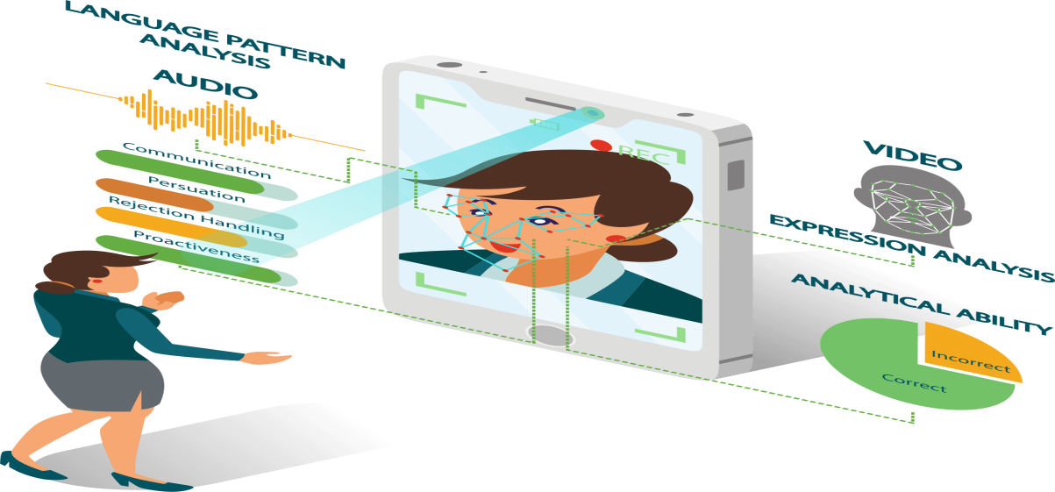

“It is a big pain to hire the right people,” Sharma said. “A lot is happening in recruitment systems, using AI to match the right people to the right team for the right projects.”

###### Customer service

Customer service departments are also getting an automation makeover with the introduction of tools like chatbots and automated [text message](https://www.businessnewsdaily.com/15044-best-text-message-marketing-solutions.html) [marketing solutions](https://www.businessnewsdaily.com/15044-best-text-message-marketing-solutions.html). These consumer-facing tools automate typical customer service interactions by answering common enquiries immediately. They only refer customers to a representative when the chatbot is insufficient for handling their needs.

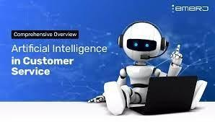

[According to Chatbots Magazine,](https://chatbotsmagazine.com/ill-never-buy-from-them-again-using-chatbots-to-avoid-bad-customer-service-e6a967360244) up to 80% of customer service interactions could be handled by a chatbot alone, offering businesses the potential to significantly cut costs associated with conventional customer service.

**Did You Know?**

###### Sales

An algorithm will never be able to take a client out for coffee or negotiate a deal as effectively as a trained salesperson. Yet automation can free up time for these human-centric interactions, since [McKinsey estimates that a third](https://www.mckinsey.com/business-functions/marketing-and-sales/our-insights/sales-automation-the-key-to-boosting-revenue-and-reducing-costs) [of all sales tasks can be automated](https://www.mckinsey.com/business-functions/marketing-and-sales/our-insights/sales-automation-the-key-to-boosting-revenue-and-reducing-costs). Here are some examples of those tasks.



* + **Searching leads:** Predicting when customers might benefit from being contacted
  + **Invoicing:** Checking credit, and [invoicing new and existing clients](https://www.businessnewsdaily.com/15964-how-to-create-an-invoice.html)
  + **Processing orders:** Order processing, stock management and upselling queries
  + **Tracking shipments:** Dispatch, delivery, and return notifications; payment and refund acknowledgments
  + **Managing clients:** Account management, including regular check-in emails

###### 5. Human resources

Given the predictable and repetitive nature of HR duties – like payroll and timesheets – digitization can transform the efficiency of a department. By reducing mistakes caused by human error, such as an HR employee forgetting to update submitted timesheets, it’s possible to automate performance management, paid holidays and absenteeism record keeping.

Software can raise flags if quotas are reached or missed, while maintaining accurate records updated in real time. There are even utilities that automate onboarding using Google forms, including prewritten emails, event scheduling and the distribution of training materials.



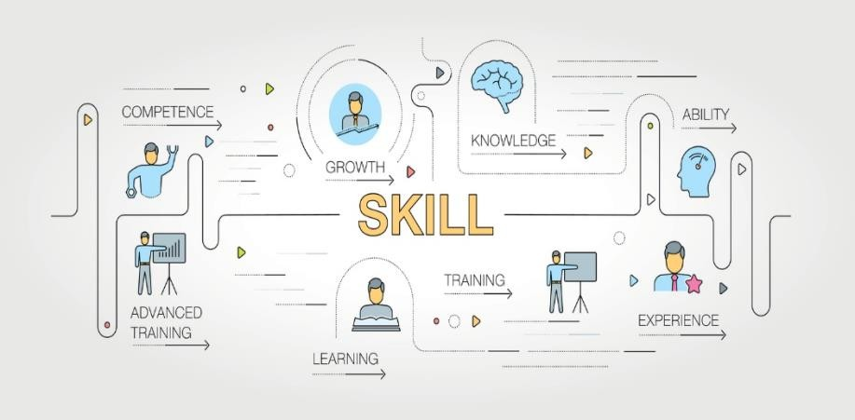

Automatic for the people

Opportunities to [automate common workplace processes](https://www.businessnewsdaily.com/15909-workplace-automation-benefits.html) are everywhere, which is why automation is becoming a common element of every business. This includes providing good customer service, streamlining the hiring process or managing marketing campaigns more efficiently. As technology improves, more tasks will become suitable for automation.

**CHAPTER-6**

**BUSINESS PLANS OF AI**

## Business Plan Template

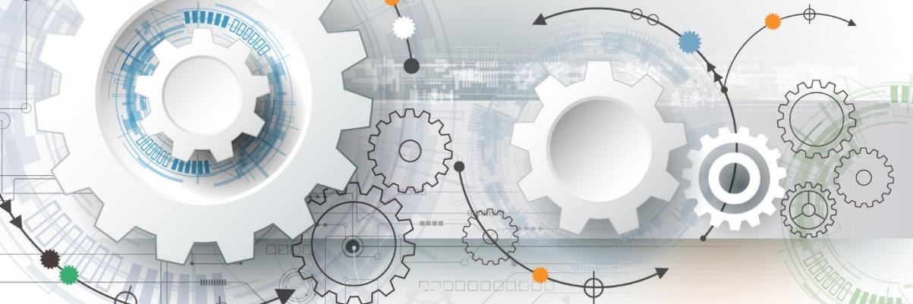Bit documents can also be embedded onto any website! Here's is Bit document that you can interact with and see in it's entirety:

Executive Summary

The executive summary is one of the most important parts of your business plan. It’s an opportunity to provide an overview of your current company state. It helps to explain where you are going and why you will be successful.

Describe the problem you are solving and ultimately the need for your target market. It’s important to include market analysis to back up your points. Explain how your solution fits in to solve the problem you have identified.

*BIT TIP: Before you begin, understand who the audience is for this business plan. Is it internal use only for you and your founding team? Is it for investors as you seek funding? Make sure to keep the reader and purpose in mind as you create your executive summary and business plan.*

*We are including a video, that will provide you with additional advice and guidance. Depending on your industry and unique value proposition you can customize your interactive* [*Bit.ai*](http://bit.ai/) *business plan template to meet your needs.*

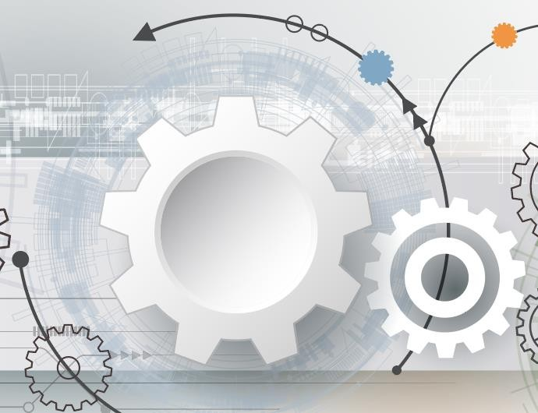Business Overview & Key Objectives

Main Objective

Your main goal with this section of your business plan is to explain why your business is in the right place at the right time. Prove that you have the correct trajectory for future success!

Utilize this section to describe your industry and the markets within it. It’s important to include research data and statistics to back up your points. You’ll want to expand on the outlook for this market space and address what the future possibilities are. Be sure to include products/developments in the industry and market that will benefit your business.

###### Key Objectives

Break out your goals into short-term, mid-term and long-term goals. They should include product development milestones, customer acquisition numbers, company hires, projections, office expansion & vertical growth.

*BIT TIP: We are including an article below from*[*Inc.com*](https://inc.com/) *that will provide you with additional tips and guidance.*



[The third in a comprehensive series to help you craft the perfect business plan for your](https://www.inc.com/jeff-haden/how-to-write-a-killer-business-plan-overview-and-objectives.html) [startup.](https://www.inc.com/jeff-haden/how-to-write-a-killer-business-plan-overview-and-objectives.html)

[inc.com](https://www.inc.com/jeff-haden/how-to-write-a-killer-business-plan-overview-and-objectives.html)

Marketing Plan

Provide an overview of your market size, statistics, and penetration.

Spend time describing your target customer. Focus on who they are, what they look like, what jobs they hold, what their interests are, what tools they use, etc.

Describe your marketing strategy. How will you go about acquiring customers? What marketing mediums are best for you to utilize. What type of budgets will you need to acquire your customers?

The last part should focus on your pricing strategy and why that strategy is the best way achieve your goals.

Include images, files, and links that show your marketing strategy.

3 Examples of Business Plan Templates

**Simple Business Plan Template**

[name of business] is a new business that will provide [description of problem that the business solves].The business will solve this problem by [description of how the business will solve the problem].

The target market for this product or service is [description of target market for this product or service].The business plans to reach its target market by [explain how you plan to reach your target market and make money].

**More**: [Use this free template to create your simple business plan in seconds](https://app.copy.ai/projects/new?tool=Freestyle&skip=1&skip-survey=true)

##### Business Plan For A Startup Template

[Company name] is a startup that is focused on solving [problem] in the [market].The executive team behind [company] is made up of [name], who has been working in the field of [field] for over 20 years.

The team has already begun to build the product, and it will be ready to launch in the next few months.The company has plans to raise $[amount] in funding, which will be used to scale the business and continue to develop new features.The company plans to focus on [market] first, then expand into other markets.

**More**: [Use this free template to create your startup business plan in seconds](https://app.copy.ai/projects/new?tool=Freestyle&skip=1&skip-survey=true)

##### Business Plan For A Food Truck Template

Hi [Name/Bank],

My name is [name], and I'm the owner of [name of food truck]. I'm so excited to share with you my food truck business plan.My food truck, [name of food truck], is a mobile restaurant that sells [food truck menu]. We sell our fare at special events, festivals, and at catering gigs.

Our target market is people who are looking for healthy and delicious food that's not too expensive.I'm starting my food truck business because I want to share the joy of eating great food with everyone. I've been cooking for years, and I think that the world needs more tasty and healthy options for people who want to eat clean but don't want to sacrifice taste or quality.

We're going to promote our business by participating in local food truck festivals and getting the word out through social media and word of mouth.

We'll also offer coupons on our website and send out newsletters to our mailing list of loyal customers.In terms of financials, we estimate that we'll have expenses of $[number] in year one, which includes startup costs, with projected revenue of $[number].

**More**: [Use this free template to create your food truck business plan in](https://app.copy.ai/projects/new?tool=Freestyle&skip=1&skip-survey=true) [seconds](https://app.copy.ai/projects/new?tool=Freestyle&skip=1&skip-survey=true)

You’ll be directed to a page that prompts you to fill out the main points of your template:

* Your business name
* Describe the problem your business solves
* Describe how your business will solve that problem
* Target market description
* Revenue model description

Whether you’re a startup or a new business, all business owners can use Copy.ai’s free business plan template to create a roadmap for success by telling the story of your business and where you plan to take it.

As AI technology continues to advance, it is becoming an increasingly popular tool for businesses to leverage when creating business plans. An AI based business plan has the potential to help entrepreneurs streamline the planning process, make better decisions, and ultimately create more successful businesses.

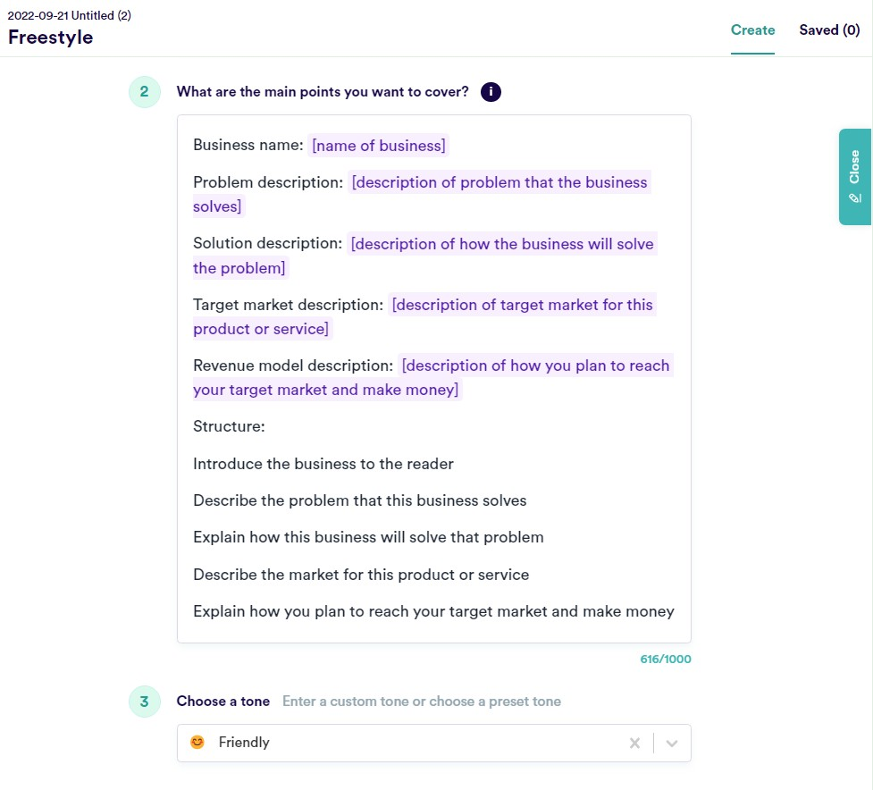

Try to be as descriptive as possible when filling out these points. The more details you add, the easier it will be for the free template tool to create your business plan format.

Let’s say you’re writing a business plan for a hair salon. Here’s how you might fill out each category:

* Business name: Shear Charm Salon
* Problem description: The closest hair salon to our location is a 20- mile drive that takes well over half an hour, even without heavy

traffic.

* Solution description: We will be a centrally-located destination for people and families of all ages, backgrounds, and styles to come for haircuts and other haircare services.
* Target market description: Men, women, and children, from babies to older adults.
* Revenue model description: We will offer services that include basic cuts, color, extensions, styles, and treatments, as well as a wide array of hair care products for retail sale.

Then, choose a tone. You can go with friendly, persuasive, and professional or something else, depending on what you’re going for.

If you submitted this information in our template, here’s the copy that the tool would generate:

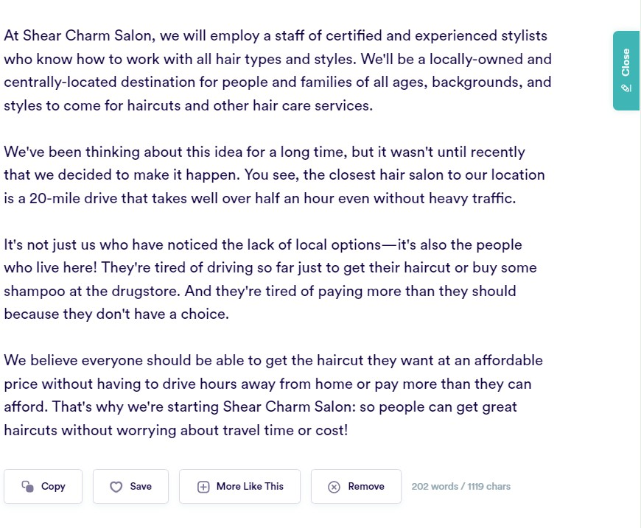

If the options provided aren’t ideal, you can have the tool generate a few more examples.

From here, you may want to tweak the generated copy to personalize it even further. You can add more information about the services and products you’ll be offering or go into more detail about the business itself.

Whatever type of business you’re starting, a simple business plan should include certain parts that detail your operational plan and business model.

The 7 parts of a good business plan

Our business plan generator is a great jumping-off point, but you may decide that you want to organize the copy into sections. Headers can help readers scan the plan and quickly find the section or details they need. If you would like to add headers, consider organizing your business plan copy under these sections.

##### Executive summary

The executive summary is where you will compel the reader to see the value of your business. Include your mission statement. Express the purpose of your business plan—are you trying to secure funding? Are you making a plan for your team to have a go-to resource for business information?

##### Company description

Properly introduce your company in this section. Explain the history of your company, share details about what problem(s) your company is solving, and where you see your business going in the future.

##### Market analysis

Lay out your competitors as well as your target audience. How are you going to effectively corner the market with your product or service? Spell that out in this section, and be sure to do your research.

##### Organization

This section is all about the “how” of your business—its structure and how responsibilities are handled and by whom. Providing an organizational chart of your management team and company is always a helpful visual for the reader and your team. Include timelines for your planned goals.

##### Marketing

The marketing plan section will describe how you plan to grow your business by attracting new customers. List the ways your marketing strategy will use social media to reach people in the area where your business is located, as well as any plans for marketing in local publications. Include a brand messaging document, so the reader knows where you stand, and conduct market research, so you can reach your target audience in the best way possible.

##### Goods and services

Let the reader know what product(s) you’re selling and its benefits to

customers. Include any statistics about the demand for what you’re offering, the pricing of the goods, and a breakdown of the product, like how it works. You should also list plans for future products or expansions.

##### Financial projections

Lay out your financial plan by listing your expenditures and revenues. Be realistic about your finances and forecasts—don’t overextend projections and potentially set yourself up for failure if you don’t reach them.

Shareholders want to see how you plan to make a profit, as well as how you plan to handle any financial setbacks. Be sure to include income statements, financial statements, and cash flow statements.

**ADVANTAGES OF ARTIFICIAL INTELLIGENCE**

Perhaps the most substantial business benefit of AI is the reduction in human error. One time-consuming process prone to human error but essential to business success is forecasting cash flow. AI technology can help a business automate objective forecasting without manual intervention.

Artificial intelligence (AI) is one of the most promising new technologies shaping 2020. Here we take a closer look at how AI is disrupting business today, and where it stands to make the most significant impact.

Before we explore how AI will benefit business, let’s take a look at what artificial intelligence actually is.

AI is the processing of data to find patterns and anomalies. **AI technology obtains and manages vast amounts of data to extract information that will enhance or transform operations efficiently and effectively**. Technologies that leverage AI can analyze and model human behavior by identifying and

simulating behavioral patterns. Over time, it can anticipate needs and make rational decisions based on its learnings and observations.

# Improve Customer

Communications and Save Costs

Chat will surpass other customer service platforms by 2021. **AI-driven chatbots allow companies to provide 24/7-customer-support by automating customer communications, making the experience even more personal**. The latest improvements in natural language processing allow “bots” to pick up conversation nuances and better mimic human speech.

According to a study by AMA, chat improves the customer journey, which leads to an increase in customer satisfaction and revenue.

Banks that have recently implemented chatbots have seen a reduction in salary and benefit costs while improving back-office efficiency. For small businesses that don’t have the budget or the human resources to have a dedicated customer service team, AI-enabled chat can fill customer service gaps.

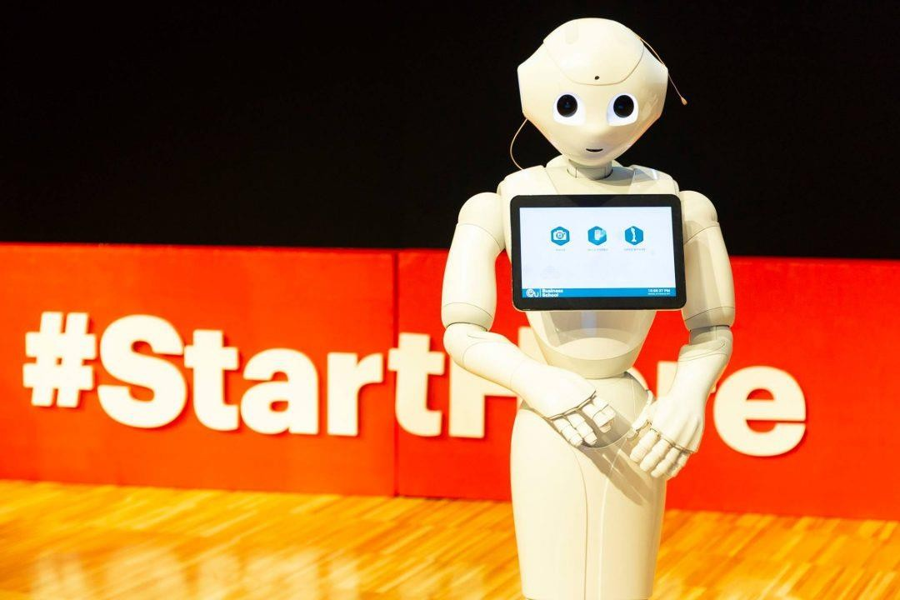

# Strengthen Brand Loyalty with Personalization

Over 60% of consumers expect a personalized experience. The challenge for most businesses, especially small ones, is that personalization takes time, effort and money. To deliver a customized experience, companies need to map out individual consumer journeys and predict the moments and offers that will increase engagement and drive sales. Personalization requires the ability to anticipate the needs of every customer. This is a tremendous task – one that that artificial intelligence can fulfill.

Brands are using data, for example from previous purchases and social media activity, to predict the type of products consumers will likely purchase. These insights allow the company to deliver tailored content and messages to customers. **Artificial intelligence can fully automate this process, identifying decision-making patterns and creating personas based on these, then driving content that AI has learnt is most successful for each persona**. Studies show that segmenting and personalizing customer communications using AI increases click-through rates by an average of 14%.

This is just the start of how automation technology and AI can improve a business’ marketing strategy.

# Streamline the Hiring Process

Another area where artificial intelligence can increase efficiency is in the recruiting process. Through automated screening calls and by automating the analysis of candidate applications, for example, AI speeds up the candidate review process. AI also helps to eliminate human bias from preliminary screenings which is good news for workplace diversity.

**In highly competitive fields with small talent pools, this technology reduces the time to fill open roles, analyzing candidate applications at a faster rate than humans can**. When PepsiCo needed to fill 250 jobs in two months, they used Robot Vera to conduct first-round interviews. Vera was able to interview 1,500 candidates in nine hours. It would have taken human staff nine weeks to interview the same number.

AI gives companies a competitive edge in the recruitment process by increasing cost-efficiency when securing talent. A study by the Talent Board

found that when companies create a positive candidate hiring experience – for example by reducing the overall time spent in the recruitment process – they cut their per-hire costs.

# Increase Forecasting Accuracy

Perhaps the most substantial business **benefit of AI is the reduction in human error**. One time-consuming process prone to human error but essential to business success is forecasting cash flow. AI technology can help a

business [automate objective forecasting](https://medium.com/%40kcherniwchan/a-fully-automated-approach-to-cash-flow-forecasting-29b3b0ef71f3) without manual intervention. This gives companies greater visibility of their future finances, empowering them to make better decisions and take actions to achieve goals.

# AI Unlocks Opportunities

According to a recent McKinsey study, companies that use AI will increase cash flow by over 120% by 2030. It’s already clear that **AI will add value to customer service, help to generate new revenue and reduce costs**. Further applications for the technology to boost business seem to be endless, limited only by human imagination.

Whether you are exploring a [career in management](https://www.euruni.edu/en/Programs/Bachelor-s/BA-Hons-in-Business-Management-Munich/Overview/Overview.html), design, human resources or marketing, to take advantage of the innovation that AI makes possible, you will need to start with a strong foundation in business fundamentals. EU Business School’s programs connect theory with practice, teaching students the skills to apply emerging technologies to continuously improve how business is done. With a broad range of courses available across four European campuses and online, there are plenty of options to find the perfect next step in your career.

###### DISADVANTAGES OF ARTIFICIAL INTELLIGENCE

**Disadvantages of Artificial Intelligence**

* + High Costs. The ability to create a machine that can simulate human intelligence is no small feat. ...
  + No creativity. A big disadvantage of AI is that it cannot learn to think outside the box. ...
  + Unemployment. ...
  + 4. Make Humans Lazy. ...
  + No Ethics. ...
  + Emotionless. ...
  + No Improvement.



**Disadvantages of Artificial Intelligence**

1. High Costs

The ability to create a machine that can simulate human intelligence is no small feat. It requires plenty of time and resources and can cost a huge deal of money. AI also needs to operate on the latest hardware and software to stay updated and meet the latest requirements, thus making it quite costly.

1. No creativity

A big disadvantage of AI is that it cannot learn to think outside the box. AI is capable of learning over time with pre-fed data and past experiences, but cannot be creative in its approach. A classic example is the bot Quill who can write [Forbes earning reports](https://www.forbes.com/sites/narrativescience/2015/10/12/eps-estimates-down-for-j-m-smucker-in-past-month/?sh=655a16097595). These reports only contain data and facts already provided to the bot. Although it is impressive that a bot can write an article on its own, it lacks the human touch present in other Forbes articles.

1. Unemployment

One application of artificial intelligence is a robot, which is displacing occupations and increasing unemployment (in a few cases). Therefore, some claim that there is

always a chance of unemployment as a result of chatbots and robots replacing humans.

For instance, robots are frequently utilized to replace human resources in manufacturing businesses in some more technologically advanced nations like Japan. This is not always the case, though, as it creates additional opportunities for humans to work while also replacing humans in order to increase efficiency.

1. Make Humans Lazy

[AI applications](https://www.simplilearn.com/tutorials/artificial-intelligence-tutorial/artificial-intelligence-applications) automate the majority of tedious and repetitive tasks. Since we do not have to memorize things or solve puzzles to get the job done, we tend to use our brains less and less. This addiction to AI can cause problems to future generations.

1. No Ethics

Ethics and morality are important human features that can be difficult to incorporate into an AI. The rapid progress of AI has raised a number of concerns that one day, AI will grow uncontrollably, and eventually wipe out humanity. This moment is referred to as the AI singularity.

1. Emotionless

Since early childhood, we have been taught that neither computers nor other machines have feelings. Humans function as a team, and team management is essential for achieving goals. However, there is no denying that robots are superior to humans when functioning effectively, but it is also true that human connections, which form the basis of teams, cannot be replaced by computers.

1. No Improvement

Humans cannot develop artificial intelligence because it is a technology based on pre- loaded facts and experience. AI is proficient at repeatedly carrying out the same task, but if we want any adjustments or improvements, we must manually alter the codes.

AI cannot be accessed and utilized akin to human intelligence, but it can store infinite data.

Machines can only complete tasks they have been developed or programmed for; if they are asked to complete anything else, they frequently fail or provide useless results, which can have significant negative effects. Thus, we are unable to make anything conventional.

**CHAPTER-7**

**Conclusion**

**Conclusion**

AI and ML have gone from experimental to essential. They are becoming increasingly key drivers of organizational performance. Many organizations struggle to realize the full value of their AI/ML initiatives and are currently stuck on POC. The focus of this document is to provide a guideline on how to effectively scale the ML journey.

To scale effectively, organizations need to have a clear business and AI strategy, a well-architected architecture to scale data and ML, and top-down organization change initiatives to help the business navigate through their AI transformation journey.

This paper provides an overview for companies to use as a starting point, understand this evolving landscape, and familiarize themselves with appropriate architectural patterns, options, and frameworks that Accenture has built.

About Accenture

Accenture is a global professional services company with leading capabilities in digital, cloud, and security. Combining unmatched experience and specialized skills across more than 40 industries, Accenture offers strategy and consulting, interactive, technology, and operations services — all powered by the world’s largest network of advanced technology and intelligent operations centers. Accenture’s 674,000 people deliver on the promise of technology and human ingenuity every day, serving clients in more than 120 countries. Accenture embraces the power of change to create value and shared success for their clients, shareholders, partners, and communities.